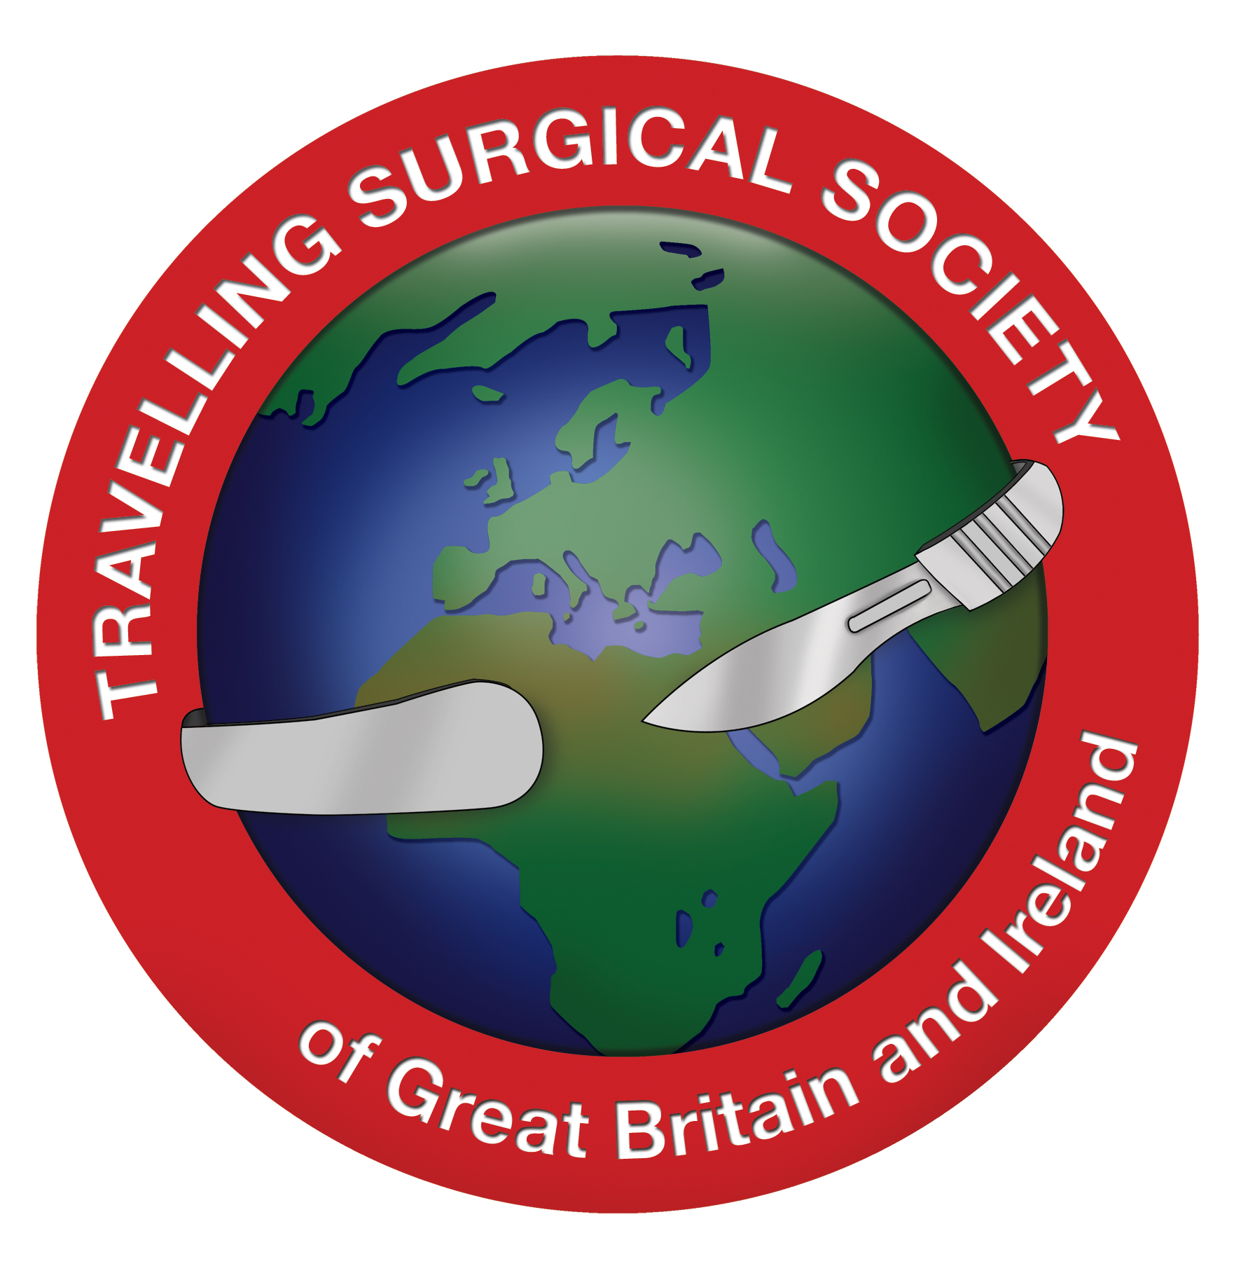
The Travelling Surgical Society of Great Britain and Ireland is pleased to invite applications for the
2020 Price Thomas Travelling Fellowship

The Travelling Surgical Society of Great Britain and Ireland is a group of surgeons who travel to various hospitals and surgical departments around the world and in the UK. They enjoy academic and clinical meetings and the purpose is to encourage educational and surgical exchanges. The Price Thomas Fellowship offers the opportunity for senior trainees and newly appointed consultants to travel outside the UK and present their work in a different environment.

The winners (usually two) of the 2020 award will travel to Milan (15-22 May 2020). During this time they will deliver at least two papers at joint scientific meetings. The bursary will cover registration fees, travelling expenses, hotel costs and all organised meals. The academic meetings will attract between 10-15 CPD points
What else happens during the week?
Outside of the academic sessions there is a full programme of cultural and gastronomic activity based in and around the city. There are three funded dinners arranged, including a main Society Dinner.
Who may apply?
Application is open to surgical trainees usually ST7 or above by May 2020 and to Consultants within 10 years of appointment who are resident in the UK. Surgeons from the following specialties may apply:
General surgery, including any of the subspecialties and General Surgeons with an interest in Trauma or Military Surgery.
What types of papers are suitable for presentation?
Fellows will be asked to provide details of two or three presentations, which they might deliver during the academic sessions. One of these must be original research work for which the presenter was a principal investigator. Clinical or basic science research is welcome. Overviews of new and evolving aspects of their sub-specialty or areas of interest are also welcome, especially since the audience is likely to represent a wide range of surgical disciplines. The Society has a particular interest in surgical and military surgical history.

Presentations should be 20 minutes each with an additional 10 minutes allowed for questions.
What is the closing date?
The closing date is 31st December 2019.
Can my spouse or partner come with me?
Yes, we encourage all members to travel with their partners, who all get on very well with each other and very much enjoy the partners’ programme. However, the Bursary would not cover a partner’s travel or expenses.
Do I need to take out Travel Insurance?
Yes: it is a condition of the bursary that you have such insurance, not just for medical cover, but also to cover the cost of travel and accommodation should you have to cancel at short notice.
Where can I learn more?
You can access further information about the Travelling Surgical Society on our website at http://www.travellingsurgeon.org.
Who were the previous Price Thomas Fellows?
2019 Major Michael Hughes travelled to Malta and presented to the University of Malta and the Mater Dei Hospital.
2018 Mr Alastair Simpson and Mr Mohan Singh travelled to Budapest, Hungary. They presented at the GI and Vascular Institutes of the Semmelweiss University
2017 Mr Andrew Healey and Mr Ernest Azzopardi travelled to Gent, Belgium. They presented papers at University Hospital Gent, Saint Lucas Hospital in Bruges and Queen Astrid Military Hospital in Brussels.
2016 Mr Joseph Hardwicke travelled to Toronto, Canada. He presented papers at the Princess Margaret Cancer Centre (University Health Network) and St Michael’s Hospital.
2015 Professor Nawwar Al-Attar travelled to Madrid. He presented papers at the Hospital Universitario du 12 Octubre and the Hospital Universitario Puerta de Hierro. His report of the visit can be found here http://www.travellingsurgeon.org/wp-content/uploads/2015/07/Nawwar.pdf
2014: Mr Fung J Foo travelled to Rennes in Brittany, France. He presented papers at the Hôpital Pontchaillou in Rennes and at the Hôtel Dieu in Nantes.
2013: Mr Jawad Ahmad travelled to Charlottesville and Richmond, Virginia, presenting papers at the University of Virginia Medical Centre and Commonwealth University Hospitals.
Jawad Ahmad’s report can be found here: http://www.travellingsurgeon.org/about-us/bursaries/jawad-ahmad/
2012: Mr Justin Davies travelled to Dublin, where he presented papers at St Vincent’s University Hospital and at the Mater Misericordiae Hospital.
2011: Mr John Simpson and Mr James Clover travelled to Switzerland. During this time they delivered papers at Centre Hospitalier Universitaire Vaudois, Lausanne, Hopitaux Universitaires de Genève and attended a meeting at The International Committee for the Red Cross, Geneva.
2010: Prof Ian Chetter and Mr David Macafee travelled with the society to Cuba and Barbados.
2009: Prof David Jayne and Prof Tim Lane, travelled with the society to Iceland.

History of the Travelling Surgical Society and the Price Thomas Fellowship:
The Travelling Surgical Society (Club, as it was then) was founded in 1924 with Lord Moynihan as its first president. The current membership consists of about fifty surgeons of whom thirty are in active practice. It is distinguished by numerous titles, honours, and Presidencies of learned organisations, including Royal Colleges.

Sir Clement Price Thomas was the third President of the Travelling Surgical Club (as it was then known) from 1952 to 1972. His other Presidencies including that of the BMA and the Royal Society of Medicine: he also became a Council Member and Vice President of the Royal College of Surgeons of England.

His son Martyn was consultant general surgeon to the Royal Gwent Hospital in Newport from 1975 to 1990, developing an interest in urology and breast cancer. He served as surgical tutor to the Royal College of Surgeons and was a popular examiner in Wales and the University of Cambridge. Having retired early in 1990 from his post in Newport, he continued in clinical practice as Consultant Surgeon to Addenbrooke’s Hospital in Cambridge. Martyn’s natural teaching ability inspired him to volunteer as a demonstrator in the Department of Anatomy.

The Price Thomas Travelling Fellowship was established in their memory.
Application form for Price Thomas Travelling Fellowship 2020
Name:  Qualifications: | Address:
Home telephone number:
Mobile telephone number:
Email address:
SpR / Consultant
Papers to be presented:
Title 1:
Abstract (not more than 200 words):

Title 2:
Abstract (not more than 200 words):

Details of current post (not more than 100 words):

Please state in not more than 100 words what attributes you would bring to the meeting of the Travelling Surgical Society:

It is essential that you obtain permission from your Deanery / Clinical Director to travel with the Society before applying.
I confirm that, if successful, I will get Travel insurance to cover the cost of the trip should I have to cancel at short notice.
Tick ☐
Signed:
Date:

Completed application forms should be emailed together with your current
Curriculum Vitae to the Honorary Secretary, Mr Graham Sunderland at grahamsunderland@btinternet.com

